BUAN 6335 - Individual Assignment 1

Steven Evans

SRE220000

**Why do CDOs Have Such Short Tenures:**

In my opinion I think CDOs are necessary, I just think their job is very difficult and, at times, overly demanding and unrealistic. The article mentions how CDO tenure is usually short, 2-2 and a half years, because of the extremely high expectations of change placed on them from the outset that are usually not met. To me this is an obvious problem. Why hire someone to make a grandiose change but only give them 18 months to make the change? This seems like an illogical fallacy within the thinking of the people defining the timeline for which the desired outcomes should be achieved. I understand that in business the need for constant innovation and growth is paramount, but there has to be some level of understanding given that the results desired are not attainable in such a short time. The article highlights this as well stating that “data transformation is typically a multi-year process at a minimum for large, legacy organizations.” The article also mentions how the problem from the outset is that CDOs are often targets because of their lack of experience in the C-Suite. Two key solutions for this and other problems that CDOs face that really resonated with me are:

**Business Partners:** The article highlights that CDO’s should find 1-2 business partners when they start to show that the changes they want to implement are attainable and be able to advocate on behalf of CDOs given that they don’t have the strongest connections within the organization as of yet.

**Involve Analytics and AI:** The article also states that using analytics throughout the data change process shouldbe utilized to demonstrate how changes can impact desired business outcomes either inside the organization or outside through the development of products. Another interesting thing the article noted is that these two things are easier to implement and have tangible value for the business. I don’t necessarily agree that AI is easier to implement, but analytics can help bolster and support many decisions that can lead to change. Having a strong analytical case for decision making is extremely important in businesses with deeply ingrained legacy systems.

**How CDAOs Can Engage Stakeholders to Foster Data Literacy and Deliver D&A Value:**

Duncans article on how data officers can better engage stakeholders is fairly interesting. Duncan attempts to give multiple strategies for how managers can better tie actions within the organization to definitive outcomes. One of the primary ways that he does this is through his idea of the Gartner VIA model. The model has three primary parts.

**Value:** Consists of finding out what is the business problem, what are the questions we should be asking, and what are the outcomes we want to achieve?

**Information:** Consists of analyzing what the data sources are to gather information, are there deficiencies in the collection process, what are the collection methods, and what are the other types of data that could be used instead?

**Analytics:** Consists of evaluating which techniques are needed to analyze, in what way are the findings expressed (deterministic, heuristics, rule based or a combination), what methods of reporting should be used, and what is the audience who will be receiving the information?

This model is then used to provide some examples of three different scenarios in which this model can be used. This approach is based on restating business goals in terms of desired outcomes. An example of how the model can be used is shown in figure A below:

**Figure A: Example Statements of Business Problems (Gartner Research, 2024)**

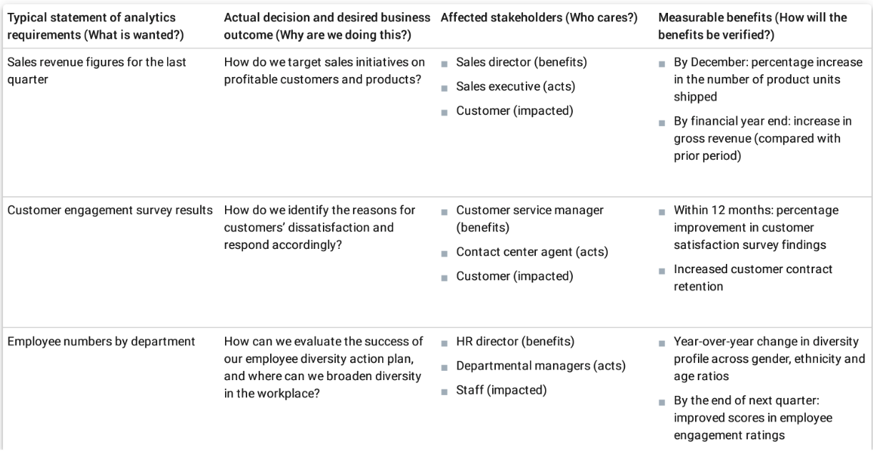

The model uses simple language to explain complex concepts, making it easier for managers to understand. The use of header questions serves as an effective way to break down analytical needs. It divides the questions into manageable and measurable parts, helping managers focus on what is necessary to achieve the desired outcome. This reminds me of another method I've encountered before: setting SMART goals, where goals are Specific, Measurable, Attainable, Relevant, and Time-bound. This method allows for thorough thought during the goal setting process and allows for forward and backwards planning to ensure project success.

**Stakeholder Action:**

Another primary idea expressed in the article is the idea that managers must engage their teams to take deliberate action. Duncan mentions that Analytical models are still only used to inform business decisions but at the end of the day action has to be taken to achieve a desired outcome, or any outcome for that matter. He then draws up a model of identifying stakeholder actions that are needed to be taken to achieve these outcomes. An image of this model is shown in figure B below:

**Figure B: Identifying Stakeholder Actions Necessary to Deliver and Accrue Business Benefits (Gartner Research, 2024)**

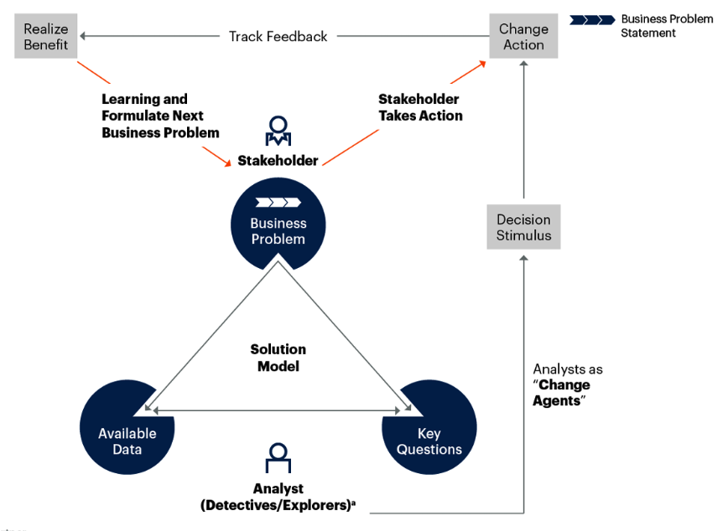

The flow is easy to follow and outlines a framework for identifying the necessary actions to deliver business benefits. It builds on Duncan's original solution model by showing how analysts act as change agents, identifying what needs to change within the business. Stakeholders should enter the situation informed about business needs and collaborate with analysts to drive actionable change that achieves the anticipated benefits.

Overall, the article does a good job of proposing a framework that aligns business goals with desired outcomes and connects that structure to the use of analytics and stakeholder actions to achieve those outcomes.

**How Should CDAOs Organize for AI and What Roles Are Required?:**

I found this article very interesting as it expands upon the growing idea and vision of AI integration in businesses. The article describes quite a few strategies that many organizations are already pursuing or should pursue should they begin a journey towards AI integration and solutions. One of the first strategies mentioned is the concept of **Fusion Teams**, more specifically AI centric fusion teams.

These Fusion teams represent a model of collaboration on AI projects by multi-disciplinary teams throughout the AI project, this is to enhance the efficiency and effectiveness of the AI initiative. These teams are made up of individuals who generally fall in one of the organizational directives in

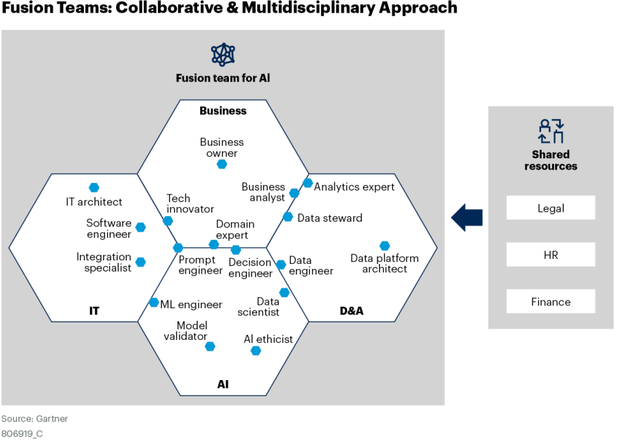

The main idea when integrating this type of team is to recognize that each group plays a pivotal role in the success of the AI initiative. Business teams understand what the business needs from AI and can communicate it to the teams via those who stand as bridges between the groups such as the Business Analyst or the Domain Expert. The AI analytics and IT teams all bring specific expertise in how to piece together their particular components to impact the project. For AI it is the gen AI models themselves, for IT it is the creation and implementation of software and architecture needed, and for Analytics it is the pulling, cleaning and storing of data so that it is made available for business insights and AI modeling. Given that AI success relies so heavily on the collaboration between these teams, it is crucial to form AI centric fusion teams from the outset of a project.

**AI Labs for Experimentation:**

Another key strategy mentioned is using AI labs during the experimentation phase. A model for how these AI labs should be set up is shown in figure 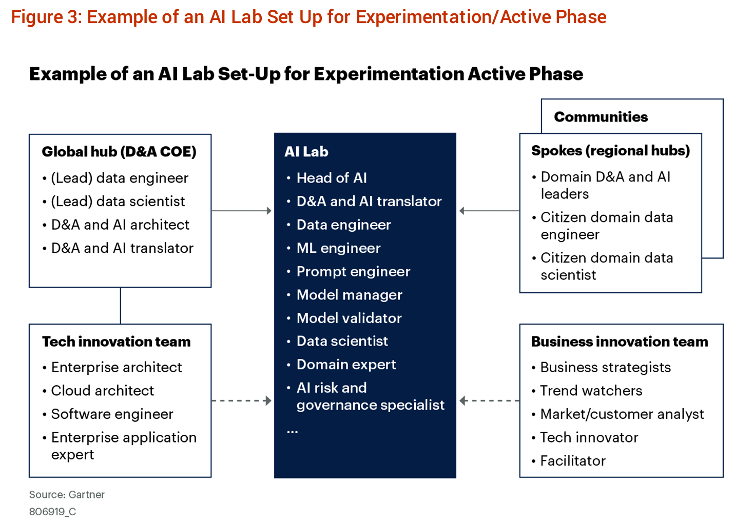

Typically these labs are used to connect AI teams to multidisciplinary teams across the organization. This allows the AI team to prototype different AI products for each discipline to see how AI can best be used and implemented within the organization either through products or department use cases. We can see in the model below that this structure has support and information coming in from many different stakeholders to achieve success with different iterations of experimentation. Because the implementation of AI is so difficult, it is important to have a large variety of individuals supporting the project from different angles. This type of strategy is very similar to fusion teams in that regard.

**Conclusion:**

Overall, this set of articles shares critical information for me as an individual about to enter the job market. It makes me think about having a similar approach as I prepare to enter into a new career in analytics/data science. It makes me think about the potential roles out there for me and how those in similar and higher level roles are thinking to create structure around modern data reformations and processes.

**References**

1. Heizenberg, J., & den Hamer, P. (2024). How should CDAOs organize for AI and what roles are required? *Gartner Research*, ID G00806919.
2. Duncan, A. D. (2024). How CDAOs can engage stakeholders to foster data literacy and deliver D&A value. *Gartner Research*, ID G00815604.
3. Davenport, T., Bean, R., & King, J. (2021, August 18). Why do chief data officers have such short tenures? *Harvard Business Review*.